**COMPUTER ORGANIZATION AND ASSEMBLY LANGUAGE**

**ASSIGNMENT#5**

**SUBMITTED BY:** HUZEFA SAIFUDDIN - 22K-5125

**SUBMITTED TO:** SIR KASHAN HUSSAIN

**DATE:** 14th October, 2023

# **TASK: 1**

# TASK: 2A

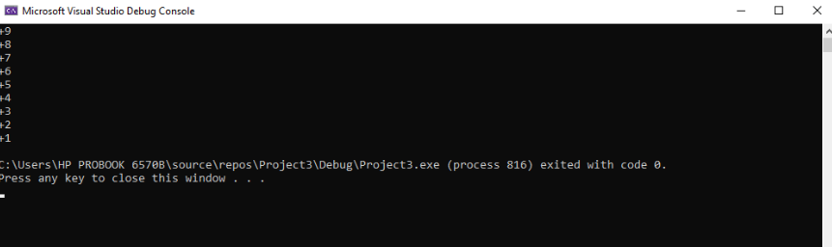

# TASK: 2B

# TASK: 2C

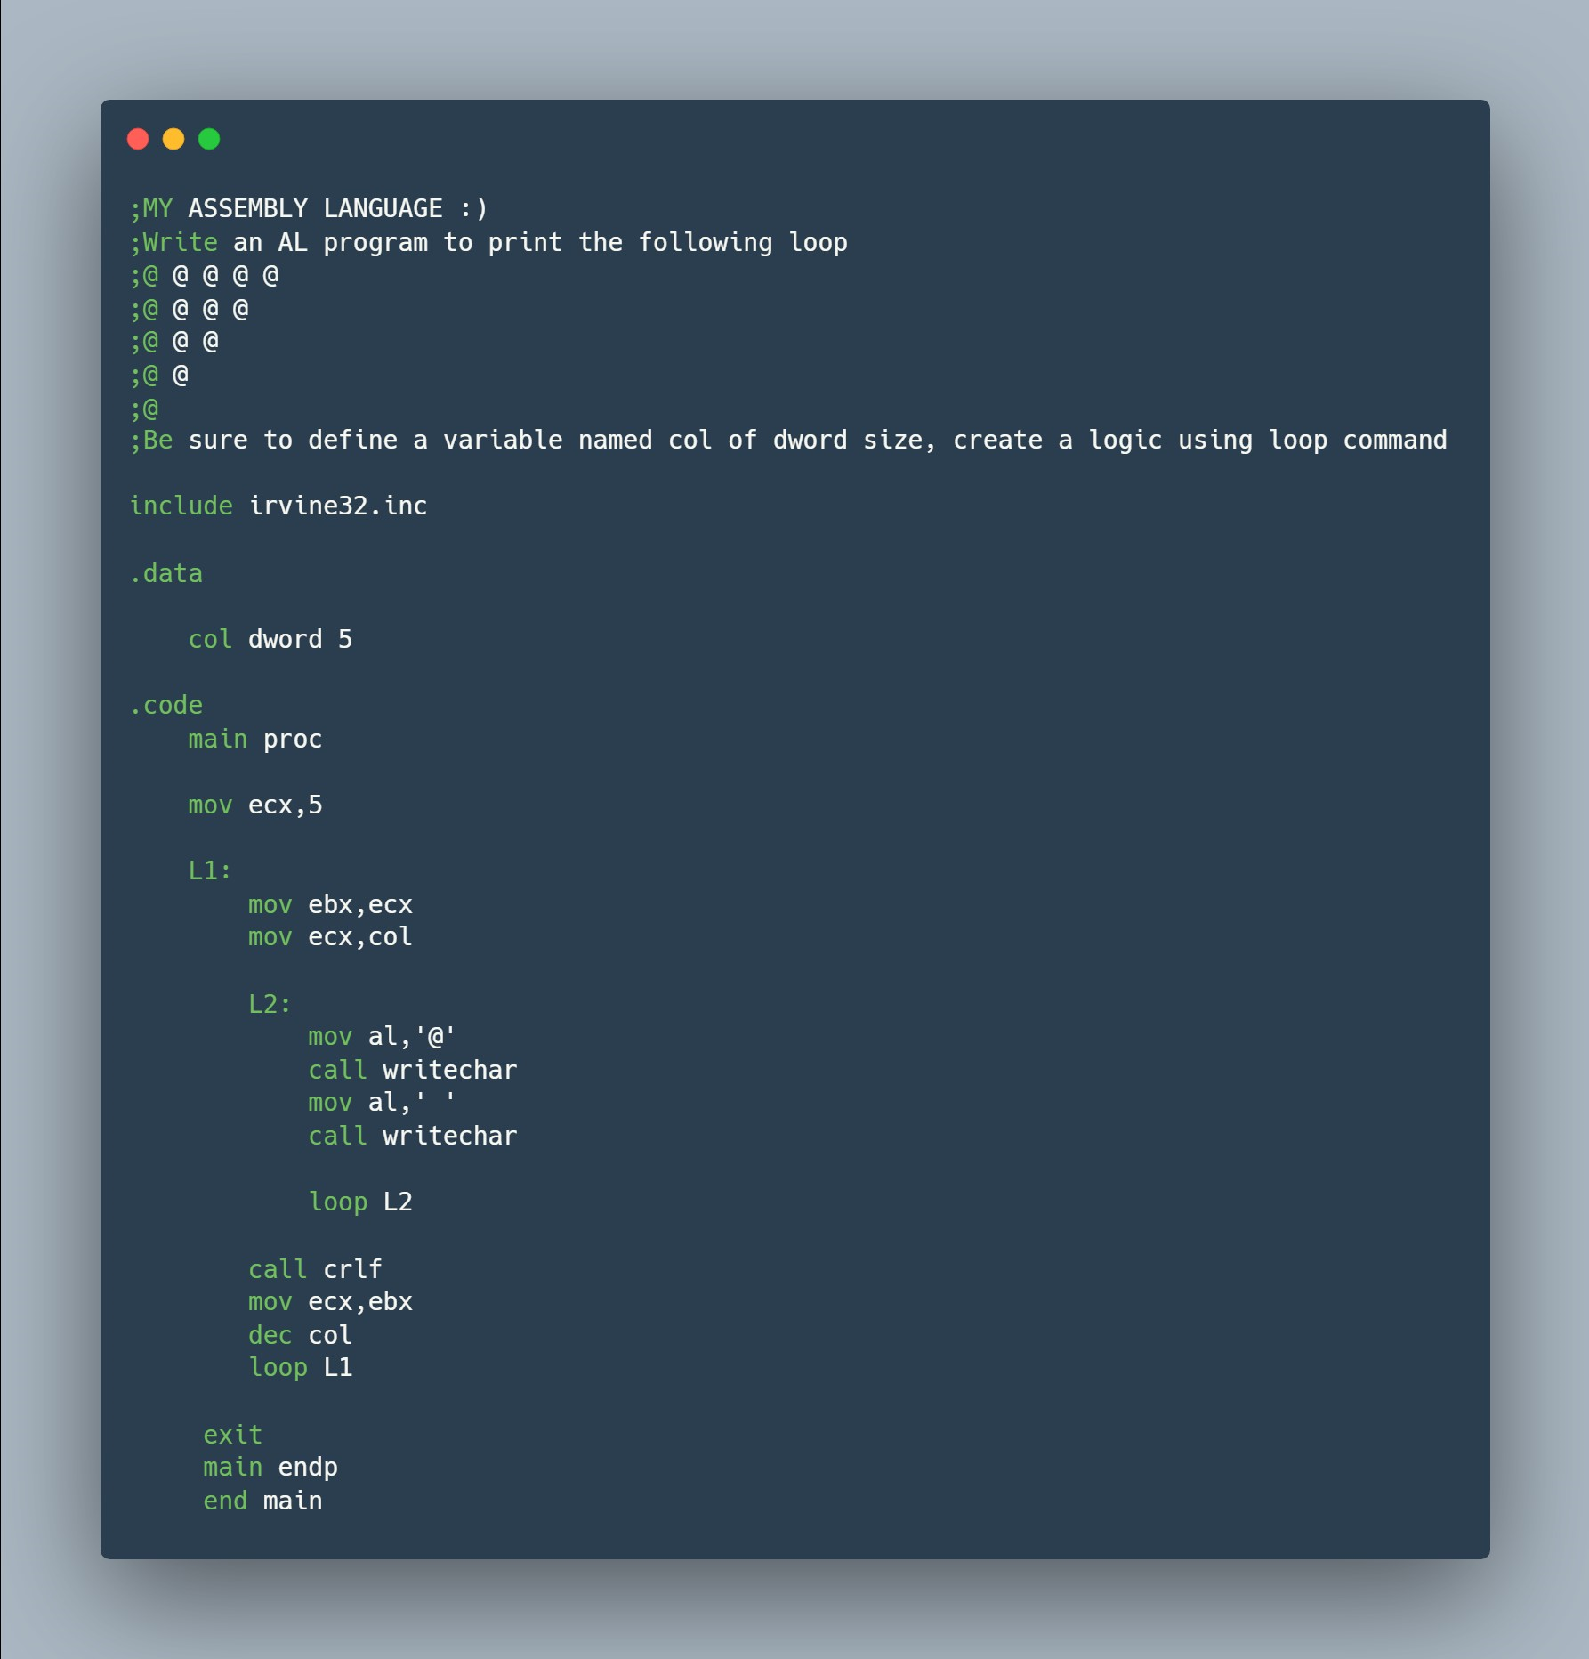

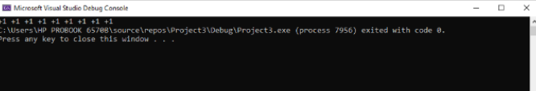

# TASK: 3

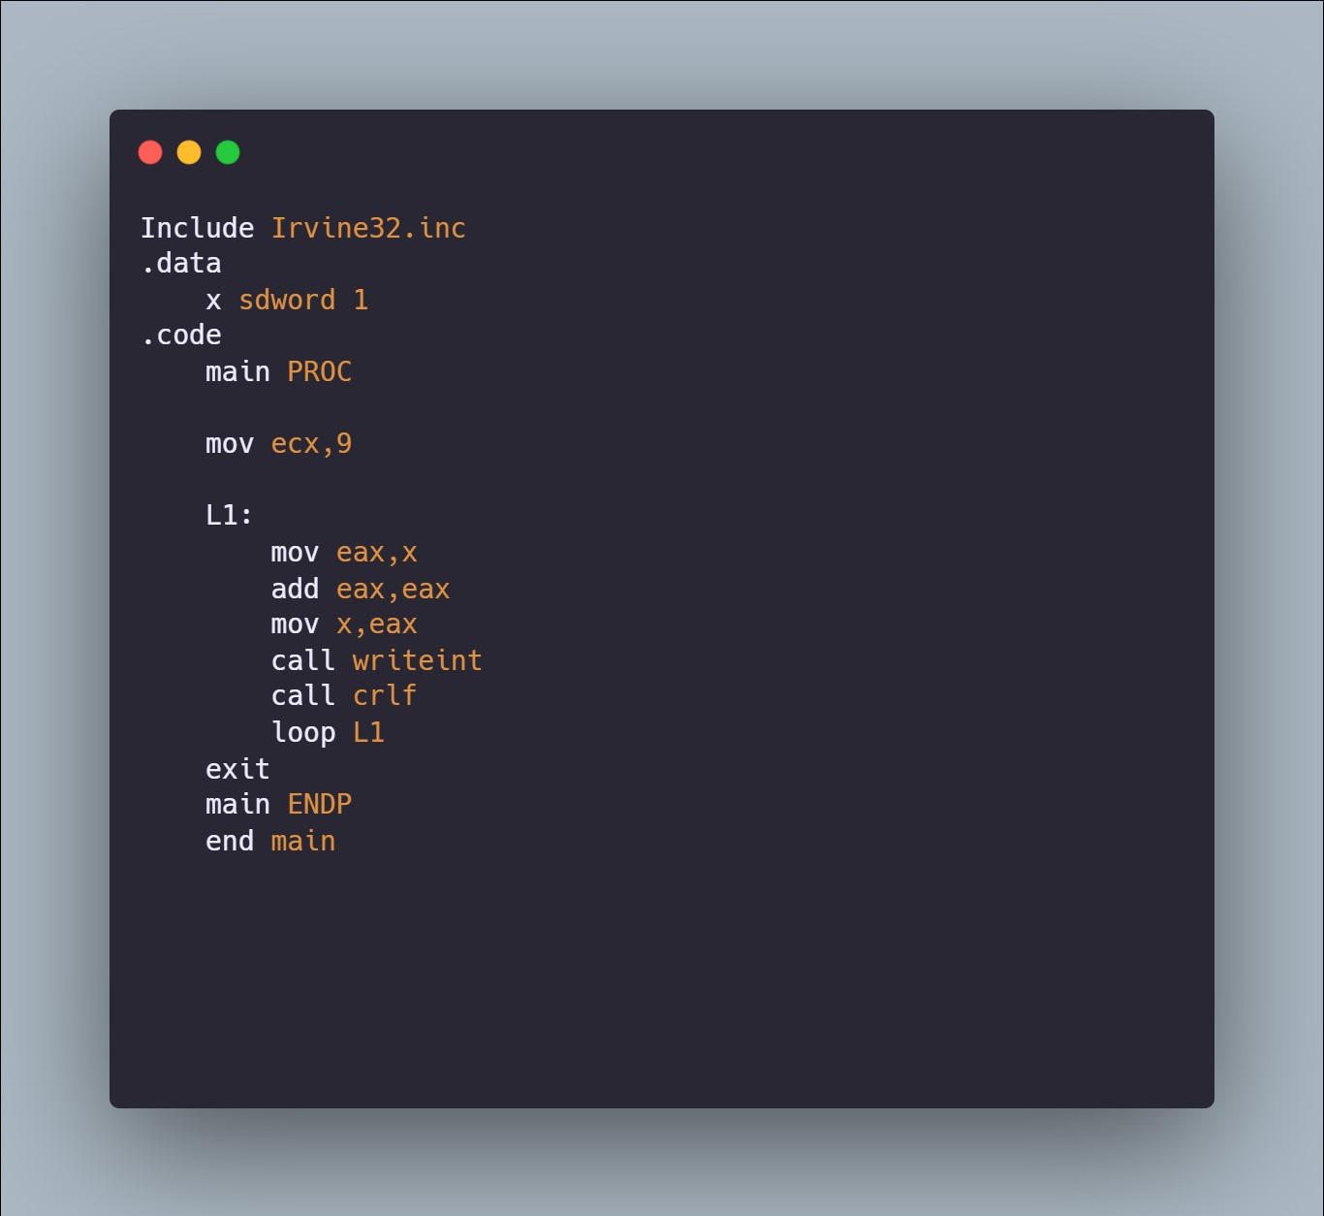

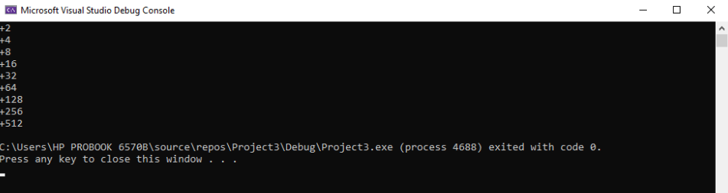

# TASK: 4

# TASK: 5

# TASK: 6

# TASK: 7